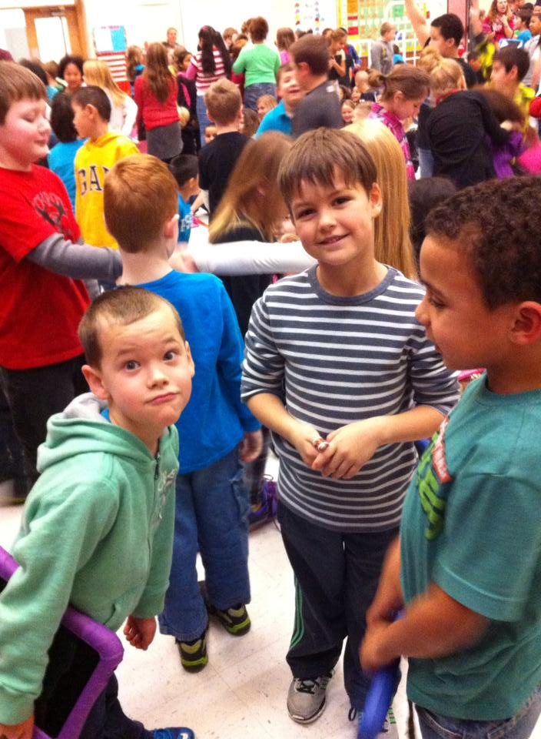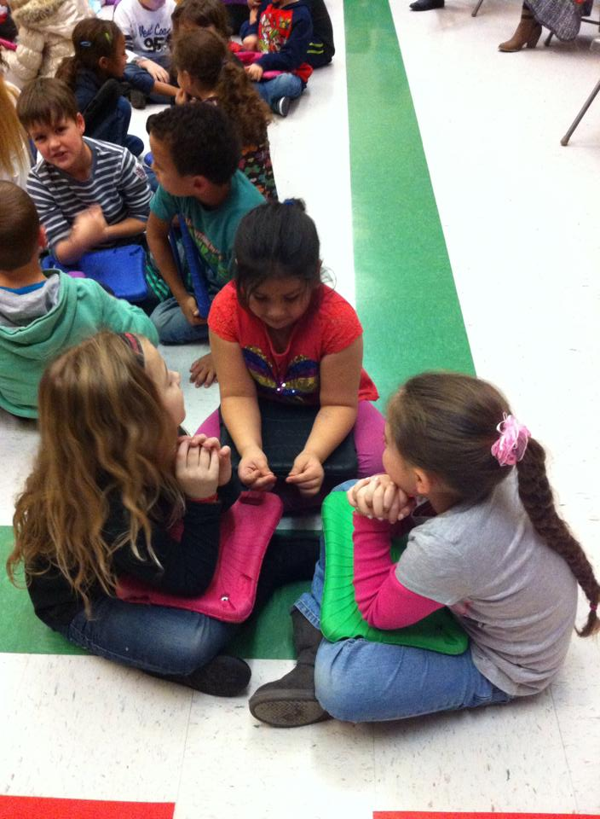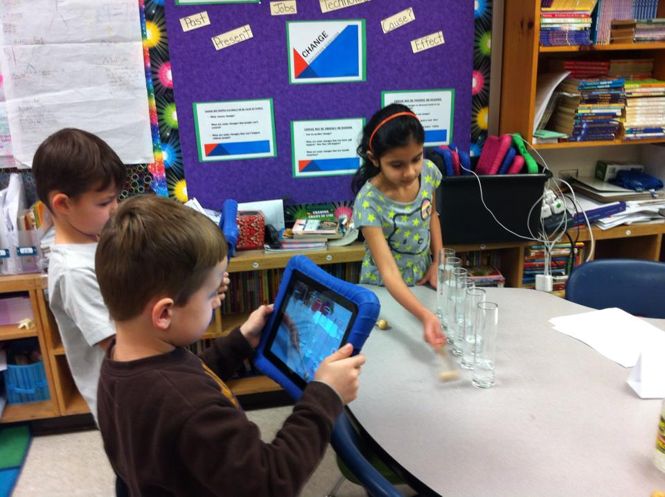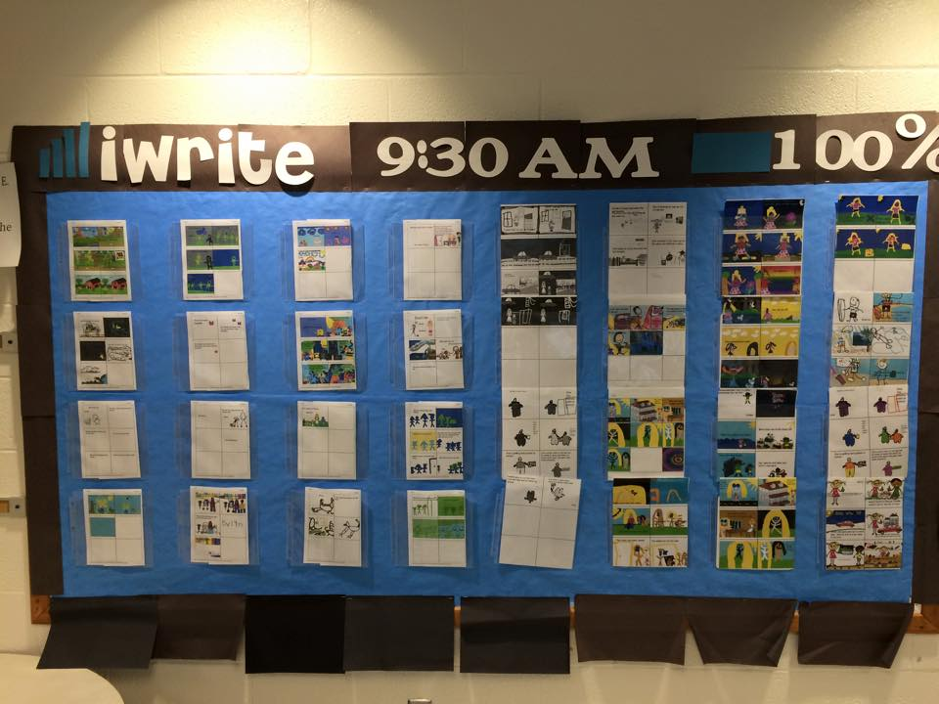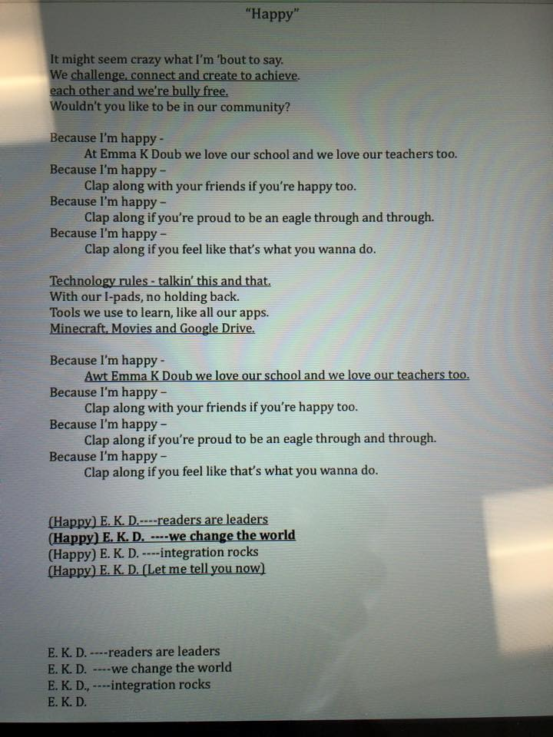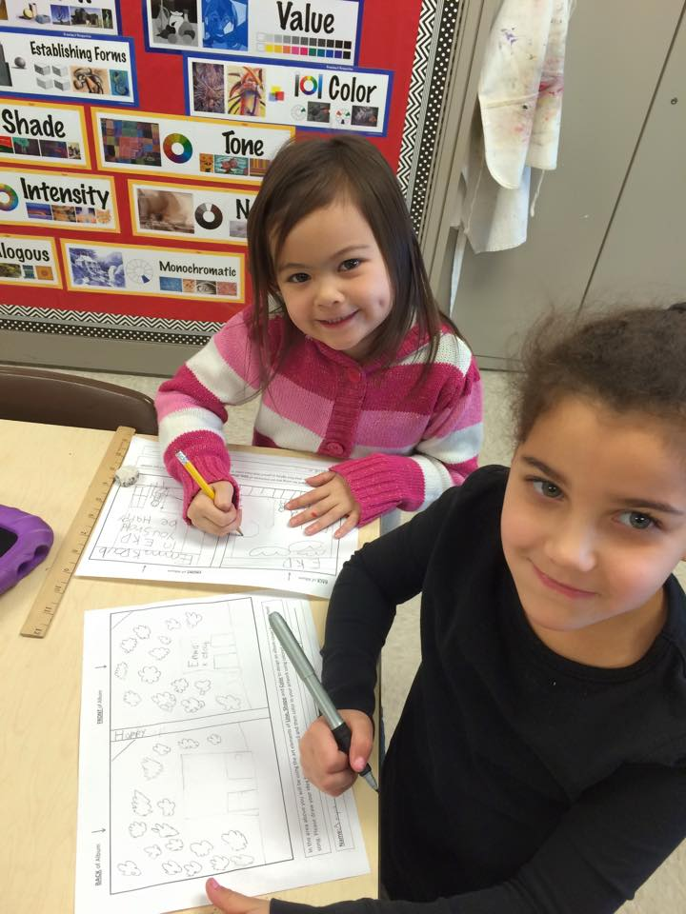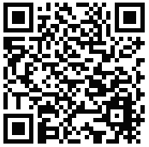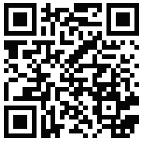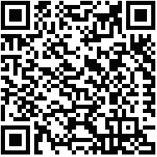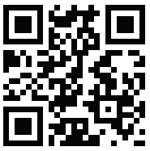

Did you hear that? Did you see those sound waves? This past month we were extremely busy learning about sound, sound waves, vibrations, and musical instruments. We practiced reading skills such as identifying the main topic and supporting details in a text, identifying reasons an author gives to support points in a text, and explaining the major difference between books that tell stories and books that give information. We also learned a new skill. We learned how to identify words and phrases in a story or poem that suggest feelings. We practiced distinguishing the difference between information provided by pictures/illustrations and information provided by words in a text. In writing, our realistic fiction stories are coming to life.

Family Book Fair Night

This month we will begin our next social studies unit. We will focus on geography and how to use maps and globes. We will be discussing ways people communicate and travel over distances. We will also learn about ways people adapt to their surroundings or environments.

Our realistic fiction stories are in full swing. Students are enjoying the freedom of writing about imaginative characters and adventures they encounter.

In math we will be using math tools, drawings, and place value properties to help us add and subtract 10 from a number.

##### **March 25th**

End of 3rd Marking Period

##### **March 27th**

School CLOSED Teacher Work Day

##### **April 7th**

School CLOSED for Spring Break

##### **March 30 – April 6th**

# Coming Up

#### Save The Date!

### February Highlights

First Grade

March 2015

Summer 2016

Emma K Doub School for Integrated Arts and Technology

**‘Cause we’re Happy** – A big THANK YOU to everyone who participated in our 100th Day Activity on TodaysMeet. We used your input to create a new school song for Emma K. Doub. Our students chose “Happy” as the song we wanted to change to fit our lyrics. We love Emma K. Doub because of how great our community, families, and teachers are. We plan on entering Rowland’s Recording Studio this month and record our song with 5th grade. Next month we are hoping to create a music video that will go along with our song. Thank you for your extra help and patients Ms. Rowland! We also made album covers with Mrs. Barnhart.

# Mrs. Chambers’ Class

* Turn in February Reading Calendars by March 6th.
* Please make sure your student is dressed with an appropriate jacket. As the weather warms up we hope to go outside when we can.
* Return your student’s literacy bag daily. These are used for instruction.
* Practice Fundation words (word ring words).
* Practice math facts.
* Sign and clean out folder daily.
* Check out Mr. Wildesen’s Facebook page for tips on Fundations practice and questioning strategies for your student.



# Reminders

# 

# Mr. Wildesen’s Class

# <https://www.facebook.com/MrWildesensClass>

Don’t forget to check out our 1st Grade Weebly! Emma K Doub has Facebook too!

<http://ekdgrade1.weebly.com>

We are also on Twitter!

@chambcor @scottwildesen @emmakdoub