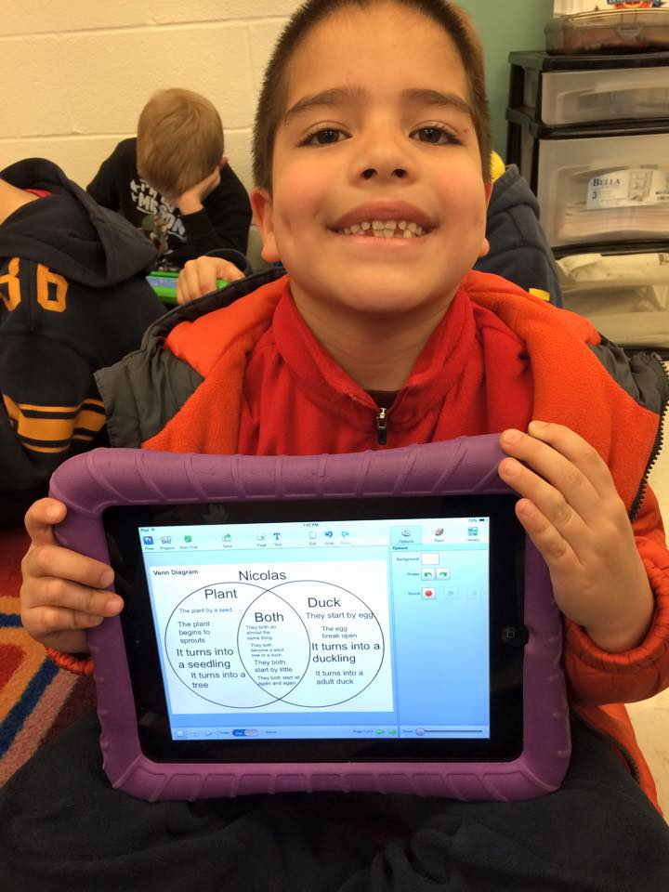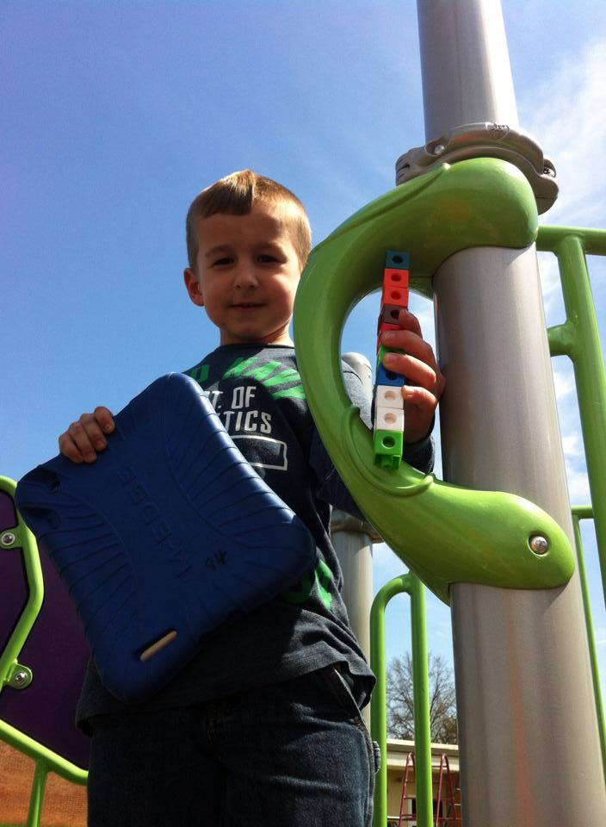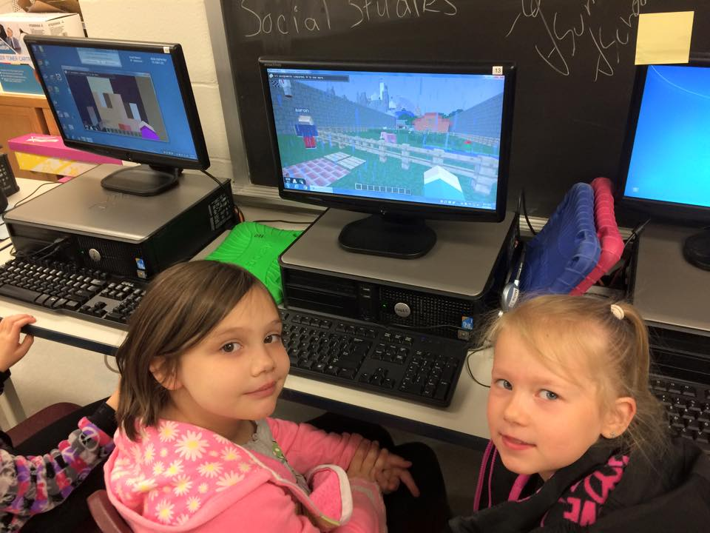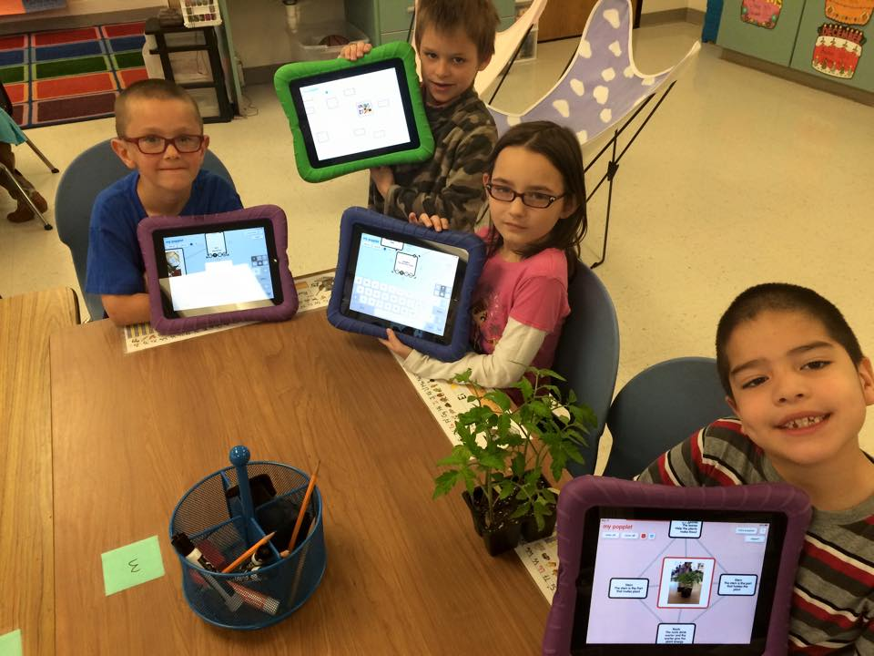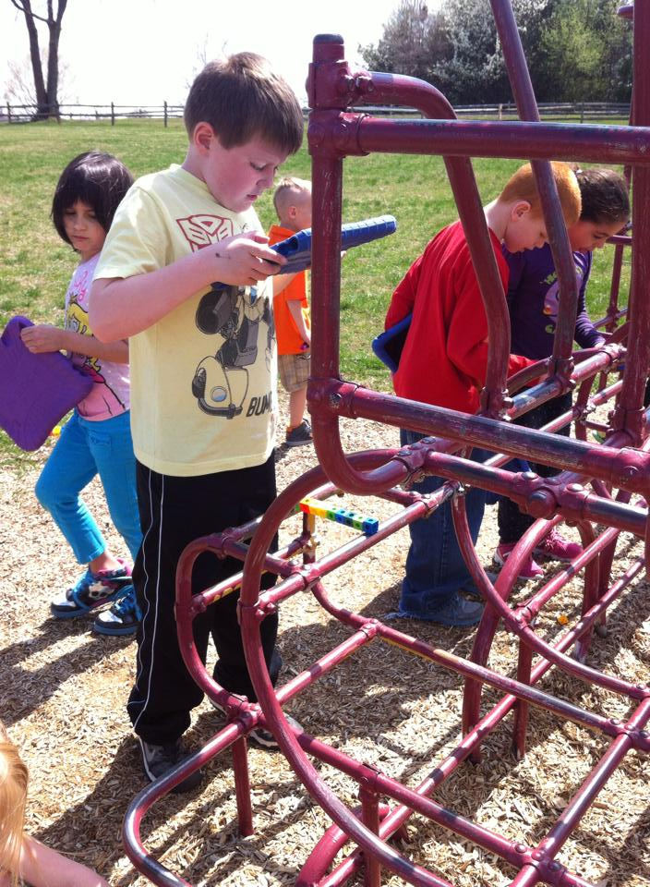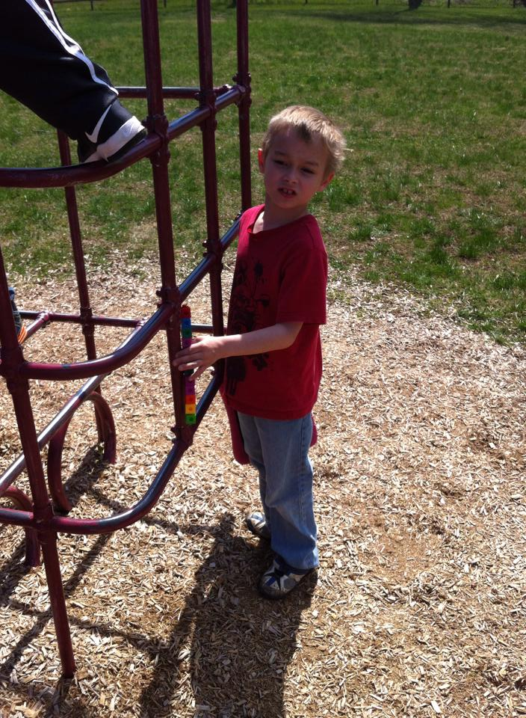

April showers bring… a lot of growing and learning at Emma K Doub. As showers are ending and growing season begins, our first graders have prepared themselves to plant our community garden. Over the past several weeks we have learned a tremendous amount about the life cycles of plants and animals. We also entered a virtual Minecraft world to experience an abundance of biomes to make observations. We studied the essentials to life and survival and then returned to the virtual world to design a structure that enabled us to survive the elements of nature. All of these learning experiences have led us to our transfer task, our community garden.

##### **June 11th**

##### Last Day of School

##### **June 9th**

##### Catoctin Zoo Field Trip

Field Day

##### **May 29th**

##### **May 25th**

School CLOSED for Memorial Day

1st & 2nd Grade

Music Program

7:00 pm @ EKD

##### **May 4th – 8th**

Teacher Appreciation Week

##### **May 12th**

Growing season is upon us. Our students have been growing and learning throughout the year but now it’s time for them to see the growing cycle for themselves. Soon, we will be planting our community garden and students will follow the growth of the plants throughout the remainder of the year. Over the summer you are all invited to visit the garden and pick some of our organically grown vegetables. Stay tuned for more details. We are currently working on nonfiction writing and students will be writing an informational text about the vegetables growing in our garden. In math we are revisiting many of the objectives we have learned during the year.

# Coming Up

#### Save The Date!

### April Highlights

First Grade

May 2015

Summer 2016

Emma K Doub School for Integrated Arts and Technology

* Turn in February Reading Calendars by May 8th.
* Please make sure your student is dressed with an appropriate jacket. It is usually still a little chilly when we go out for recess.
* Return your student’s literacy bag daily. These are used for instruction.
* Practice Fundation words (word ring words).
* Practice math facts.
* Sign and clean out folder daily.
* Check out Mr. Wildesen’s Facebook page for tips on Fundations practice and questioning strategies for your student.

**Our Community Garden**

We will be finishing out the year with a wonderful learning experience that provides for our entire Emma K Doub community. Students have learned about the life cycle of plants and animals. They have also learned about things people do that mimic plant and animal survival. Throughout the upcoming weeks, students will participate in a community garden project that will allow them observe plant growth and apply the everyday skills they have learned in first grade. Students will learn about the economics of plant growth, as well as important marketing procedures. They will also apply many of their math skills to ensure proper planting and growing during the cycle. These skills will encompass the leadership and pattern characteristics our students have encountered throughout the year.

**Catoctin Zoo Field Trip**

First Grade will be traveling to the Catoctin Zoo on June 9th. This will be a during school field trip. More information will be shared, as we get closer to the date.

**Emma K Doub PTA**

EKD is still looking for PTA officers for the 2015-2016 school year. If you are interested please contact your student’s teacher. We would love to have you join our team.



# Mrs. Chambers’ Class

# Reminders

# 

# Mr. Wildesen’s Class

# <https://www.facebook.com/MrWildesensClass>

Don’t forget to check out our 1st Grade Weebly! Emma K Doub has Facebook too!

<http://ekdgrade1.weebly.com>

We are also on Twitter!

@chambcor @scottwildesen @emmakdoub