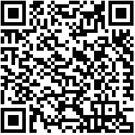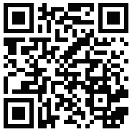

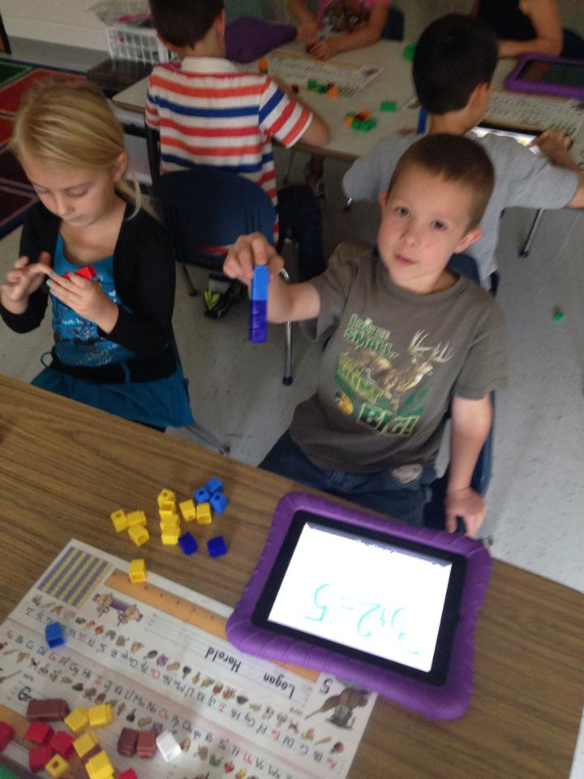

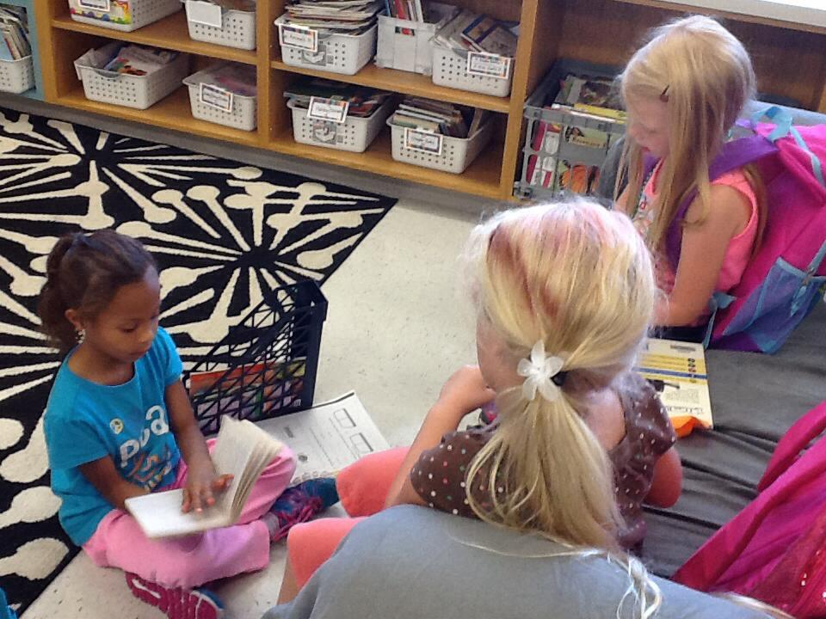

These 1st graders have really hit the ground running. We are now on our 2nd integrated unit (reading/science). Guided reading groups and writer’s workshop are well underway, and students are moving math fact levels each week! They are also developing stronger tech skills and learning new apps to help them create and achieve! Remember to look at the back of the homework sheet for the specific skills we will be learning each week. Please also help to reinforce at home the concept of following directions. Thanks for all of your support and for sharing your children with us every day!

October 17th

##### Grade 1 Field Trip to South Mountain Creamery

October 30th

9-12:30 ~ more info coming soon!

October 8th

3:00 – 7:00pm

##### Book Fair Family Night @ EKD

##### Association Day

##### Schools Closed

October 14th

##### Individual Fall Pictures

### Off and running…

# Coming Up

Unit 2 began Monday. During this unit, students will apply previously taught reading strategies and standards when reading texts on their levels. Students will also learn new skills such as asking and answering questions to find the meaning of words that are unknown, retelling the main idea or topic with supporting details, describing characters and setting, and making connections between multiple pieces of information. In addition to applying these literacy skills, students will be observing patterns in our solar system, learning about patterns that the earth experiences, and predict changes that will happen in the future.

#### Save the Date!

First Grade

October 2014

Summer 2016

Emma K Doub School for Integrated Arts and Technology

Don’t forget to check out our 1st Grade Weebly! Emma K Doub has Facebook too!

<http://ekdgrade1.weebly.com>

We are also on Twitter!

@chambcor @scottwildesen @emmakdoub

* Please sign the homework/behavior sheet every day.
* Please clean out the keep at home side of the folder daily.
* Composition books will come home at the end of a Fundations unit. Please look at the unit test, sign, and return to school the next day.
* Remember to return signed spelling menus every Friday.
* This week Fundations help and Dolch sight words came home in literacy bags. Please use these as resource to help your child practice reading.

Want to be involved in your child’s classroom? We would love to have you! We are interested in having volunteers come to work with small groups and reinforce previously taught skills for reading and math facts. Don’t know how to tap out words, not sure what high frequency words are? No worries! First grade teachers and/or our lead teacher would be happy to give you a quick training! If interested please contact your child’s teacher.

# Volunteers

# Mrs. Chamber’s Class

# <https://www.facebook.com/pages/Mrs-Chambers-First-Grade/638695966152481>

# **Check out our class Facebook Pages**

# Reminders

# Mr. Wildesen’s Class

# <https://www.facebook.com/MrWildesensClass>