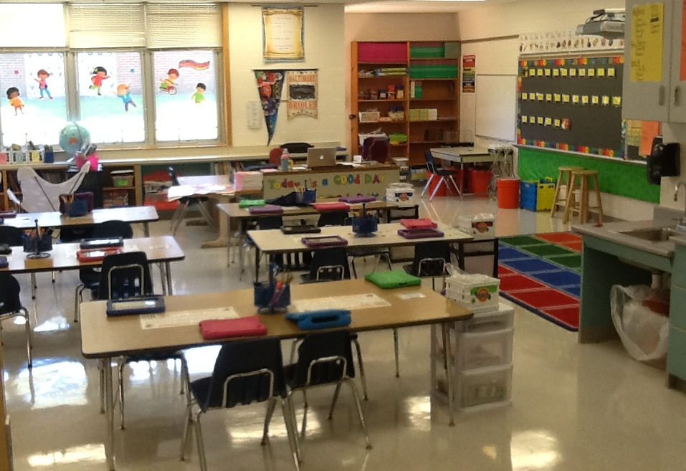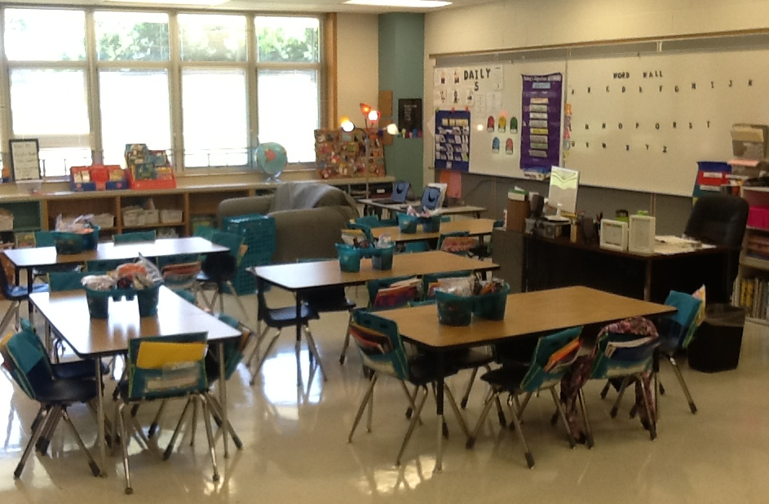

September 11th

4:00 pm

##### Destination

##### Imagination Parent Meeting

September 24th

5:00 – 7:00 pm

McDonald’s on

Sharpsburg Pike

##### McTeacher Night

##### Book Fair

##### @ EKD

October 5-10

September 17th

4:00 pm

##### PTA

##### Walkathon

### Welcome Back

We are very excited to have such a great start to the 2014-2015 school year. On the first day of school we began our first unit of study, Leadership and Symbols. We began by reading the story *The Rainbow Fish* and discussing ways we can be shining leaders in our classroom and school this year. Students developed many different ideas ranging from sharing, being respectful, helping others, reading, writing, and working together. We have also begun reading text closely and retelling stories with great detail. Writer’s Workshop has also begun and students are currently writing and illustrating their own small moment story. In math, we have hit the ground running with relating counting to adding and subtracting.

# Coming Up

In the weeks ahead we will transition into reading like a historian and investigating U.S. Symbols. We will then apply what we have learned about symbols and their meaning. Together we will create a classroom symbol that is unique us. In Art Integration, each student will create a personal symbol that represents a unique leadership quality about themselves. In writing, we will continue creating and critiquing our own small moment stories and personal narratives. Math will continue to consist of practicing addition and subtraction strategies that help students become more efficient and accurate.

#### Save the Date!

First Grade

September 2014

Summer 2016

Emma K Doub School for Integrated Arts and Technology

Don’t forget to check out our 1st Grade Weebly! Emma K Doub has Facebook too!

<http://ekdgrade1.weebly.com>

We are also on Twitter!

@chambcor @scottwildesen @emmakdoub

* Please sign the homework/behavior sheet every day.
* Please clean out the keep at home side of the folder daily.
* Please provide a change of clothes in your child’s book bag.
* Be on the lookout for spelling menus this month. Each week students will bring home a spelling menu with a list of spelling words at the bottom. Please do a different activity with your child each night. On Thursday nights do a practice test to prepare them for Friday spelling assessments.

Want to be part of something special? Our school is currently looking for classroom volunteers. Whether it’s reading with one child at a time, working with a small group, or reading to the whole class, everyone benefits from your help. Students could also benefit from your participation and help in other daily reading activities. If you are interested in volunteering, please contact your child’s teacher. We look forward to hearing from you and thank you in advance for your time.

Data and Analysis (Ashton & Madisyn)

# Volunteers

# Mrs. Chamber’s Class

# <https://www.facebook.com/pages/Mrs-Chambers-First-Grade/638695966152481>

# **Check out our class Facebook Pages**

# Reminders

# Mr. Wildesen’s Class

# <https://www.facebook.com/MrWildesensClass>